

***RBC online banking screen shots***

***By: CuseyHub***

***Date: December 12, 2018***

The ***Royal Bank of Canada (RBC)*** is a Canadian multinational financial services company and the largest bank in Canada by market capitalization. The bank serves over 16 million clients and has 80,000 employees worldwide.[4] The bank was founded in 1864 in Halifax, Nova Scotia, while its corporate headquarters are located in Montreal, Quebec and Toronto, Ontario.[4][2] RBC's Institution Number (or bank number) is 003. In November 2017, RBC was added to the Financial Stability Board's list of global systemically important banks.

***References:***

<https://en.wikipedia.org/wiki/Royal_Bank_of_Canada>

<https://www.youtube.com/watch?v=N4pKyhwBq4w&list=PL0u7mzfWrc9fIRUdhDaJEYIgqLC2iPceY>

***Bills & Managing Payees***

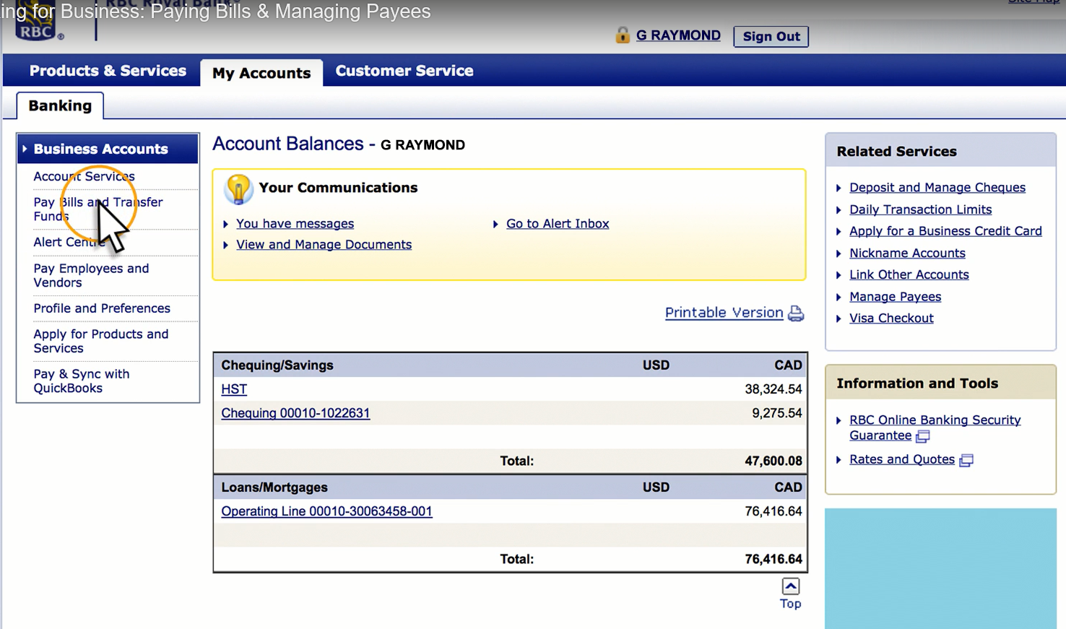

Click on the ***Pay Bills and Transfer Hype Link*** from the Business Accounts navigation panel in the left side of the screen.

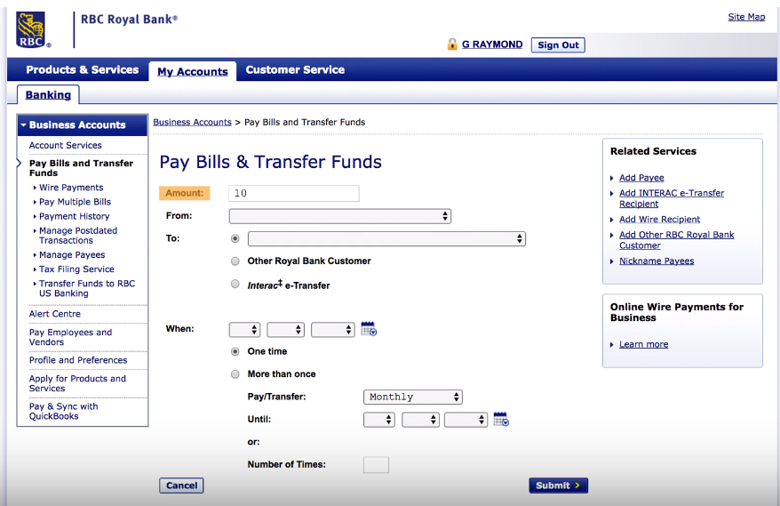

Click the ***Submit Button*** at the lower right hand cornor.

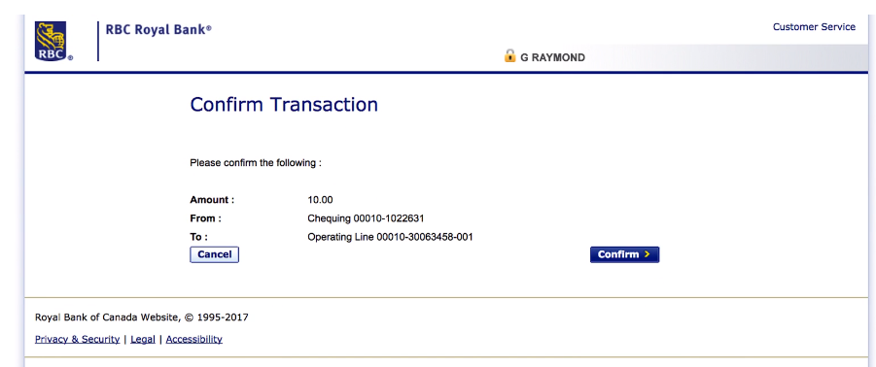

Click the ***Confirm Button*** at the lower right hand cornor.

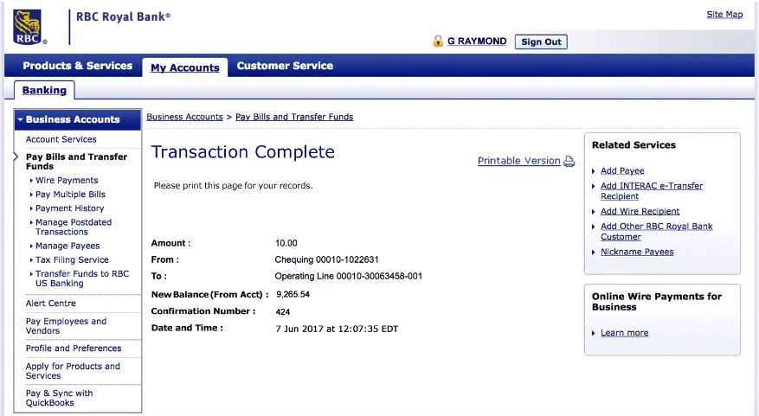

See the Confirmation Number in the middle of the page.